Circuits Laboratory Manual

# Objective

To utilize electronics prototyping equipment to create simple circuits that can be integrated with microcontrollers such as Arduino UNO. The goal of this lab is to gain an understanding of the basic components such as: resistors, photoresistors, LEDs and breadboards.

# Background

## **Breadboard**

A breadboard is used to prototype a temporary circuit. You can build, test and analyze a circuit without any permanent connections. It is made up of terminal strips and power rails. The terminal strips are used to hold any number of components in place and make electrical connections in a horizontal row. The power rails are the long vertical strips and are used to facilitate power (+) and ground (-) connections by placing them all in one column. For some general background on how such a breadboard actually works, take a look at the YouTube video about breadboarding at: [https://www.youtube.com/watch?v=6WReFkfrUIk.](https://www.youtube.com/watch?v=6WReFkfrUIk)

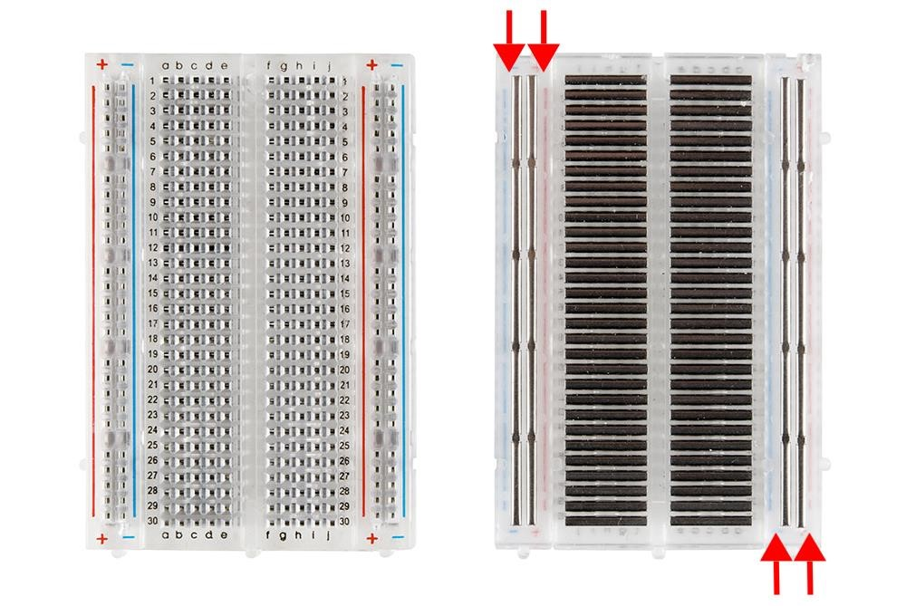

*Figure 1 : Breadboard*

## **Ohm’s Law**

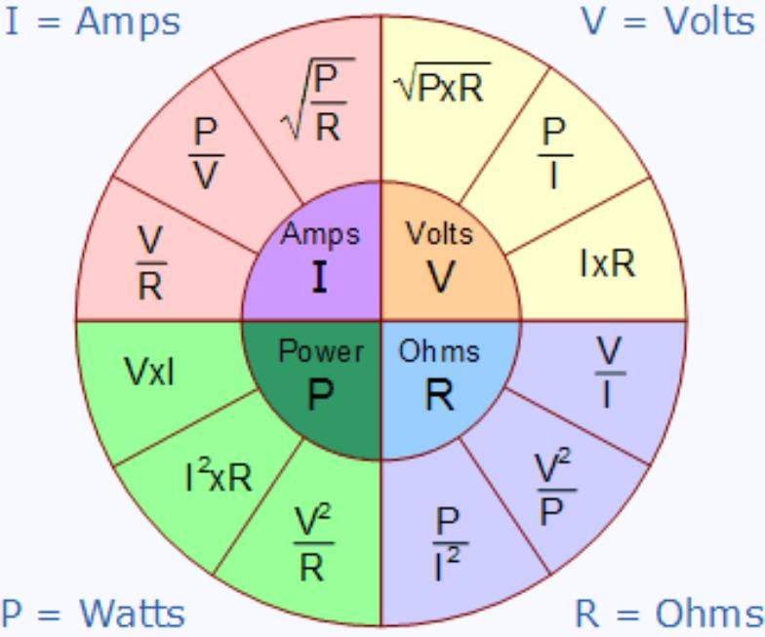

*Figure 2 : Ohm’s Law diagram* Ohm’s law describes the relationship between Voltage, Current, Resistance, and Power. Typically, voltage and resistance are inputs in the design phase, meanwhile current and power are characteristics you aim for. For example, you want to design a smartwatch that has long battery life, therefore uses less power. Given a 3.7V lithium battery, your only option is raising the (effective) resistance to lower the current. This is grossly simplified but illustrates a use for Ohm’s law.

## **Circuit configuration**

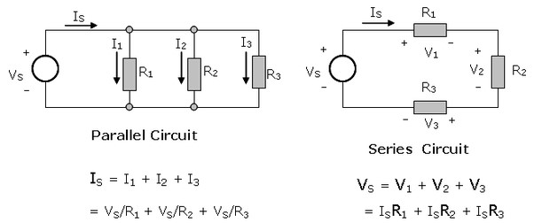

### Figure 3 : Types of circuits

In a parallel configuration, the loads have the same voltage and share the current between them.

In a series configuration, the loads have the same current and share the voltage between them. The above circuits are built in real life using light bulbs below.

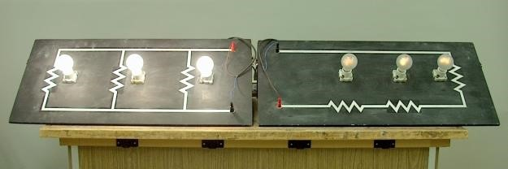

### Figure 4 : Parallel vs series circuit

Notice how the lights placed in parallel are brighter than the ones placed in series. This is because each light in the circuit on the left has more voltage than the series circuit.

## **Multimeter**

Multimeters are used to measure Resistance, Current, and Voltage. Resistance and Voltage measurements can be done carelessly since the multimeter resistance will be high, hence protecting the multimeter. However, when the current is measured, the multimeter resistance will effectively be zero. This is why multimeters often have a separate hole for current readings.

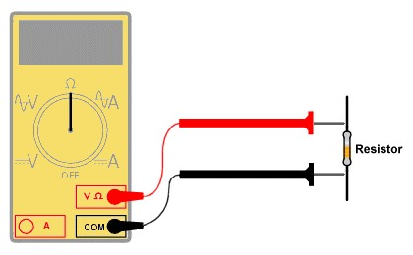

### Figure 5 : Multimeter reading resistance

When measuring resistance, you need to make sure that the circuit is unplugged from your power supply. Then place the probes on either side of the component you wish to measure. Make sure that the correct settings are selected, and the probes are connected to the right terminals.

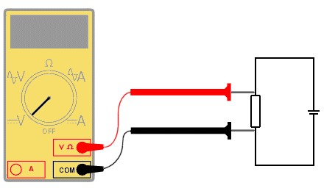

### Figure 6 : Multimeter reading voltage

Reading voltage is similar to resistance except make sure the circuit is plugged in. The voltage across a component is a measure of the difference in electrical potential from one side of the component to the other and so the meter must be attached as shown above.

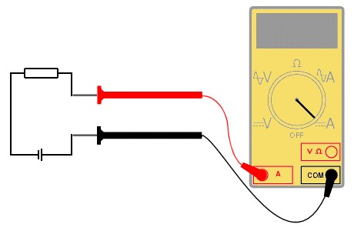

### Figure 7 : Multimeter reading current

Current readings are the only readings that can damage the multimeter. If the current is too high, the internal fuse will burn. Current is a measure of the rate of flow of electrons through the circuit. To measure the flow of current, the circuit must be broken, and the multimeter must be placed in the circuit such that the current flow goes through it. This is shown above.

## **Batteries**

Most students will use batteries in their projects, so it’s important to understand the values stated on batteries. The 2 most important values are voltage (Volts V) and capacity (Amp-hours Ah). A battery with a capacity of 1 amp-hour should be able to continuously supply current of 1 amp to a load for exactly 1 hour, or 2 amps for 1/2 hour, or 1/3 amp for 3 hours, etc., before becoming completely discharged.

## **Resistors in Light Emitting Diode (LED) Circuits**

An LED (Light Emitting Diode) emits light when an electric current passes through it. The simplest circuit to power an LED is a voltage source with a resistor in series. The resistor is used to limit the current through the LED and to prevent burning it. The resistance of the resistor is easy to calculate with [Ohm’s law](http://www.resistorguide.com/ohms-law/) and [Kirchhoff’s circuit laws.](http://www.resistorguide.com/kirchhoff-law/)

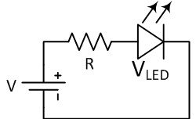

### Figure 8 : Resistance calculation in a series circuit

V is the voltage source, VLED is the LED voltage and I the current in this series circuit. The rated LED voltage which is around **2V** for most of the LEDs is subtracted from the voltage source, and then divided by the desired LED operating current. This way you can find the right resistor for LED and power source.

# Design for Manufacturing considerations

When prototyping a circuit you should keep a few things in mind.

* Component selection: before making any circuits or soldering anything, take some time to make sure that all your components will work together. Check the manuals and manufacturers websites for information about each component. If using one, make sure your micro controller has enough I/O for the given task.
* Voltage: start thinking about what volage each component in your circuit uses. For example, if you have a 5V sensor, you can run that directly off on an Arduino. If you want to use an ESP32 you need to supply separate power for the sensor since the ESP runs on 3.3V.
* Current: the next thing to take into consideration is how much current the circuit will be drawing. Some components may pull more current than the wires can handle or that a power source can provide.

Finally, think about how you are going to house all your electronics. While having wires going every which way may “work”, it is not very presentable and robust.

# Apparatus and Equipment Overview

The following equipment and materials will be used:

* 1 x Arduino UNO + USB A to B Cable
* 2 x 1 kΩ resistor
* 2 x 10 kΩ resistor
* 3 x 220 Ω resistor ● 3 x LEDs
* 1 x Breadboard
* 8 x Male-male jumper wire

# Review Questions

How much current does a 60 Watt heater draw if it’s being powered by a 120V circuit?

60W/120V = 0.5A

______________________________________________________________________________

You measure an automotive headlight bulb to have a resistance of 5 Ohms. Given that car batteries are 12 Volt batteries, how much current will it draw, and what’s the power rating?

12V/5Ohm = 12/5 A

______________________________________________________________________________

In the 2008 hit movie ‘Pineapple Express’, the main characters fall asleep in their car with the headlights on and the radio playing. When they wake up, they realise that they slept for 18 hours and the car is dead. Given a car battery has 100 Ah capacity and assuming the stereo was an 80 Watt system, and both headlights are on. How long did it take the car to die?

(12/5 A * 2 lightbulbs + 80W / 12V) = 11.47A

100Ah/11.47A = 8.72 Hr

______________________________________________________________________________

**Hint:** Use the previous answer for this question. Your answer will be less than 10 hours. If you did not get this, double check all your previous answers.

Let all the resistors in the light bulb circuit in Figure 4 have the same value and both power supplies provide the same voltage. How much more power is the left circuit using?

* X is the difference of power between the two circuits

|  |  |
| --- | --- |
| Left | Right |
| 1/Rt = 1/R1+ …  1/Rt = 3/R  P = VI  = V^2 / R  P = 3V^2 / R | Rt = R1+…  Rt = 3R  P = VI  = V^2 / R  P = V^2 / 3R |

X(3V^2/R) = V^2/3R

X (3/R) = 1/3R

X = 1/R^2

.: the left circuit is using 1/R^2 more power

______________________________________________________________________________ **Hint:**

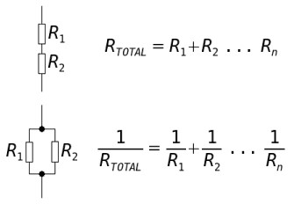

## Figure 9 : Resistance calculation in series or parallel circuit

What is the probe configuration (in the circuit and on the device) to be able to measure current with a multimeter?

______________________________________________________________________________

# Part A- Parallel vs Series LED

We have seen the theory about parallel and series connection. Now we’re going to implement both circuits and see what actually happens.

1. **Connect** 1 LED and 1 resistor (220 ohm) as shown in the figure below.

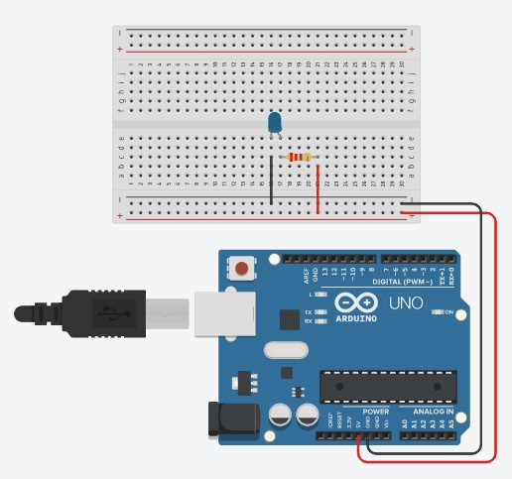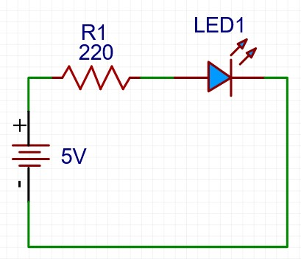

## Figure 10 : One LED

2. **Add** an LED and a resistor (220 ohm) in parallel as shown below.

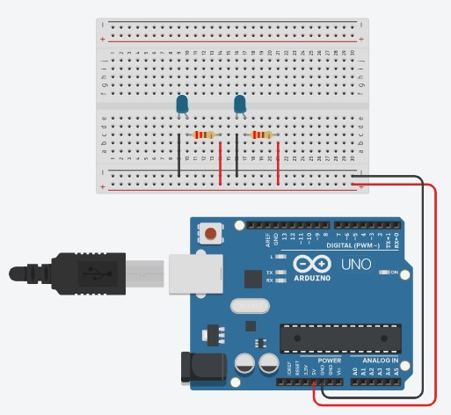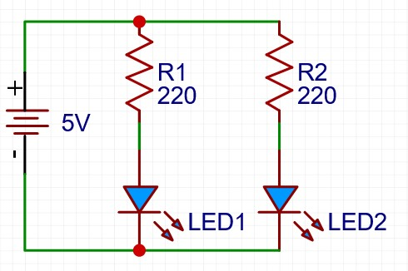

## Figure 11 : 2 LED in parallel

3. **Add** a third LED and resistor (220 ohm) in parallel as shown below.

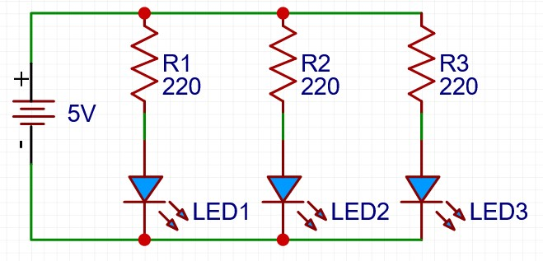

## Figure 12 : 3 LED in parallel

1. Now **go back** to step 1.
2. **Add** a LED in series as shown below.

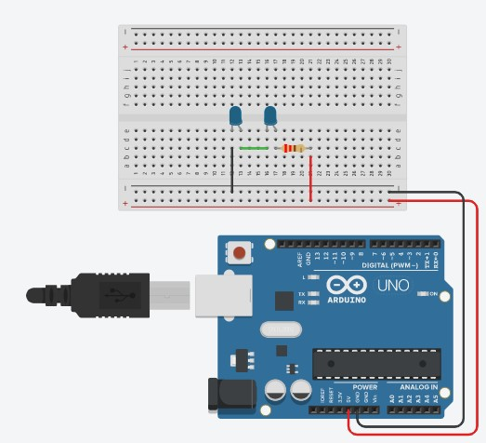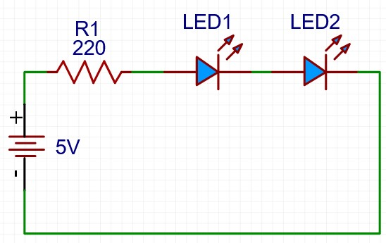

## Figure 13 : 2 LED in series

6. **Add** a third LED in series as shown below.

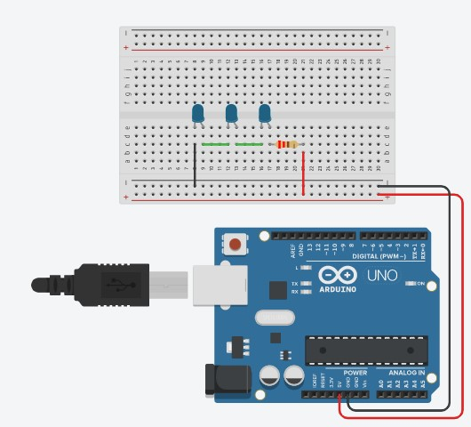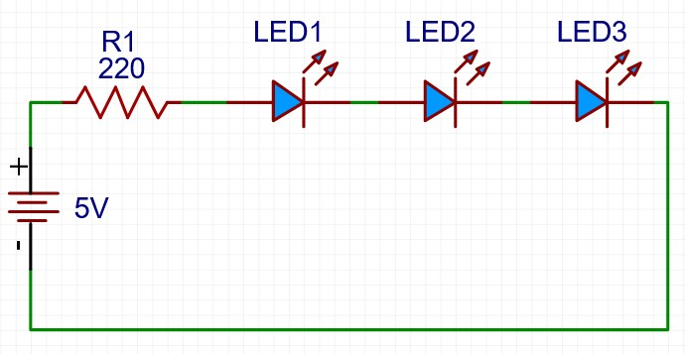

## Figure 14 : 3 LED in series

**Q1. What happened? Is it what you expected? Calculate the total voltage of the 4 components assuming 4 mA in the circuit.**

When adding more LED bulbs into the circuit when they were in parallel it was noticed that they had kept the same brightness although connected to the same circuit. This was expected because as the equations for Current and Resistance in the parallel depict ( I = I1+ … In , R = 1/R1 + … 1/Rn) there was no change to the voltage given by the equation V=IR where Voltage (what the light bulbs use) will remain constant because the total of all Resistance remains the same. This result gives us that in parallel Vtotal = V1 = V2 = V3…=Vn

When the LED bulbs are in series, we noticed a change in diminishing returns as we added more bulbs to the circuit. This was initially surprising due to how fast they had lost their radiance. The change in brightness is because of the change in voltage due to each LED and the resistor requiring a certain amount of voltage. This can be seen in the equation of V=IR where due to the series only containing one total path the current remains constant, but as you increase resistance the amount of voltage required also increases (V = I * (R1 + … Rn)). This results in the equation Vtotal = V1 + V2 + … Vn.

______________________________________________________________________________

______________________________________________________________________________

# Part B- Impact of a resistor

In this part we are going to see the impact that the resistor has on the voltage and the current in a circuit.

1. **Repeat** step 2 from part A but change your resistors from 220𝛺 to 1k𝛺 and then to 10 k𝛺.
2. **Repeat** step 5 from part A but change your resistor from 220𝛺 to 1k𝛺 and then to 10 k𝛺.

**Q2. What do you notice?**

As you increase the resistance the LEDs become darker

______________________________________________________________________________

______________________________________________________________________________

# Part C - Using a multimeter

In this part, a multimeter will be used to measure the voltage and current across a circuit. The measurement on this part will be simulated via the website called Tinkercad.

1. **Go** to Tinkercad.com, **sign in** or **create** an account.
2. **Select** “Circuits” from the menu on the left and **create** a new project.
3. **Drag** an Arduino Uno, a breadboard, 1 LEDs, 1 resistor and 1 multimeter from the components list on the right, to the middle of the blank workspace.
4. **Click** on the resistor, an input box will be displayed, **enter** 220𝛺 as the resistor value.
5. **Click** on the multimeter and **change** your multimeter measurement mode to voltage in the input box or with the circular button on the side of the multimeter.
6. **Connect** your circuit as shown in the diagram below. **Start** the simulation by **clicking** the ‘Start Simulation’ button at the top right beside the Code button.

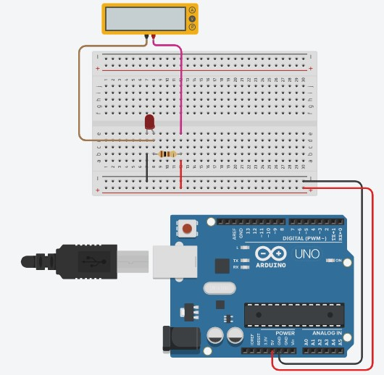

## Figure 15 : Voltage measurement

1. The multimeter should display a voltage value, **record** it in the table below. **Change** your resistor value to 1 k𝛺 and then 10 k𝛺, **record** the voltage value.

*Table 1 : Voltage measurement of an LED circuit*

|  |  |
| --- | --- |
| **Resistor** | **Voltage across the resistor (V)** |
| 220𝛺 | 2.98 |
| 1 k𝛺 | 3.11 |
| 10 k𝛺 | 3.23 |

1. **Measure** the current in the circuit. Modify your tinkercad circuit to resemble the diagram below.

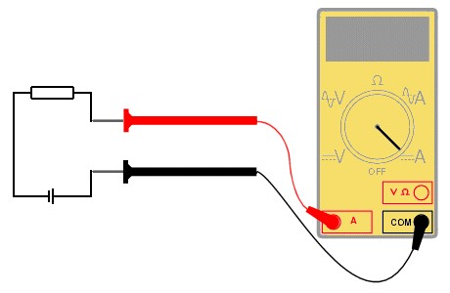

5

V

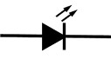

## Figure 16 : Current measurement

1. The multimeter should display a current value, **record** it in the table below. **Change** your resistor value to 1 k𝛺 and then 10 k𝛺, **record** the current value. *Table 2 : Current measurement of an LED circuit*

|  |  |
| --- | --- |
| **Resistor** | **Current in the circuit (mA)** |
| 220𝛺 | 0.323 |
| 1 k𝛺 | 3.11 |
| 10 k𝛺 | 13.5 |

1. Assuming you have a battery of 2 Ah, **calculate** how long the battery will last. *Table 3 : Life calculation of a battery*

|  |  |
| --- | --- |
| **Resistor** | **Battery life (h)** |
| 220𝛺 | 2 Ah / (0.323 *10 ^-3) = 6191.95 |
| 1 k𝛺 | 2 Ah/ (3.11 * 10 ^-3) = 643.087 |
| 10 k𝛺 | 2 Ah/ (13.5 * 10 ^-3) = 148.148 |